**School Management System**

**DATA BASE**



Submitted by:

Muhammad Yasir

Submitted to:

Syed Shayan Ali Shah

Semester: 4th BSDS(Group-B)

Session 2023 –2027

**INSTITUTE OF MANAGEMENT SCIENCES**

**HAYATABAD, PESHAWAR (2025)**

School Management System



**PROJECT REPORT**



**1. Introduction to the working of the system:**

A database model has been developed at **IMSciences** to efficiently manage student records, including information about students, departments, instructors, and courses. This system streamlines operations, supports queries, and ensures future scalability.

1. **Problems in the existing system:**

A database model has been developed at **IMSciences** to efficiently manage academic records, encompassing information about **students, departments, instructors, and courses**. The system is designed to streamline administrative operations, facilitate complex queries, maintain data consistency, and support future scalability for institutional growth.

1. **Entity - Relation Diagram:**

c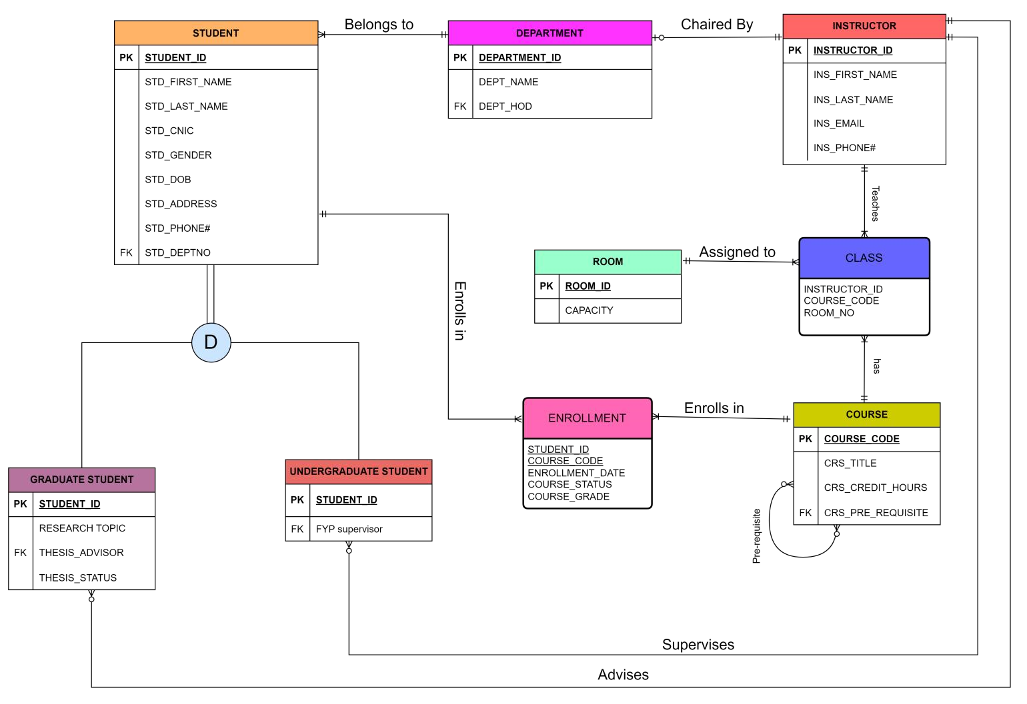

# 4. ERD Transformation

## Student

A strong entity

Student (Student_ID, First_Name, Last_Name, CNIC, Gender, DOB, Address, Phone#, DeptNo)

## Graduate Student

Student’s Subtype

Graduate Student (Student_ID, Thesis_Advisor_ID, Thesis_Status)

## Undergraduate Student

Student’s Subtype

Undergraduate Student (Student_ID, FYP_Advisor_ID)

## Department

Strong Entity

Department (DeptNo , Dept_Name , Dept_HOD)

## Instructor

A regular entity

Instructor (Instructor_ID, First_Name , Last_Name, Email, Phone#)

## Room

A regular entity

Room (RoomNo , Capacity)

## Course

Recursive relation

Course (Course_Code, Course_Title, Credit_Hours, Pre_Requisite_ID)

## Class

An associative entity

Class (Instructor_ID, Course_Code, RoomNo)

## Enrollment

An associative entity

Enrollment (Student_ID, Course_Code, Enrollment_Date, Course_Grade, Status)

**NOTE:**

___________ Indicates primary key

Indicates foreign key

# 5. CONSTRUCTION OF RELATIONAL SCHEMA

* TOP DOWN APPROACH
* BOTTOM UP APPROACH

## TOPDOWNAPPROACH

**Identified entities:**

* Student
  + Graduate students
  + Undergraduate students
* Instructor
* Department
* Course
* Room
* Class  Enrollment

**Relations:**

**Student** (Student_ID, First_Name, Last_Name, CNIC, Gender, DOB, Address, Phone#, DeptNo)

**Graduate Student** (Student_ID, Thesis_Advisor_ID, Thesis_Status)

**Undergraduate Student** (Student_ID, FYP_Advisor_ID)

**Department** (DeptNo , Dept_Name , Dept_HOD)

**Instructor** (Instructor_ID, First_Name , Last_Name, Email, Phone#)

**Room** (RoomNo , Capacity)

**Course** (Course_Code, Course_Title, Credit_Hours, Pre_Requisite_ID)

**Class** (Instructor_ID, Course_Code, RoomNo)

**Enrollment** (Student_ID, Course_Code, Enrollment_Date, Course_Grade, Status)

# Normalization

**Student** (Student_ID, First_Name, Last_Name, CNIC, Gender, DOB, Address, Phone#, DeptNo) *1NF :* Already in 1NF as there is no repeating group.

*2NF :* Already in 2NF as there is no Partial Functional Dependency. *3NF* : Already in 3NF as there is no Transitive Dependency.

**Graduate Student** (Student_ID, Thesis_Advisor_ID, Thesis_Status)

*1NF :* Already in 1NF as there is no repeating group.

*2NF :* Already in 2NF as there is no Partial Functional Dependency. *3NF* : Already in 3NF as there is no Transitive Dependency.

**Undergraduate Student** (Student_ID, FYP_Advisor_ID)

*1NF :* Already in 1NF as there is no repeating group.

*2NF :* Already in 2NF as there is no Partial Functional Dependency.

*3NF* : Already in 3NF as there is no Transitive Dependency.

**Department** (DeptNo , Dept_Name , Dept_HOD) *1NF :* Already in 1NF as there is no repeating group.

*2NF :* Already in 2NF as there is no Partial Functional Dependency. *3NF* : Already in 3NF as there is no Transitive Dependency.

**Instructor** (Instructor_ID, First_Name , Last_Name, Email, Phone#)

*1NF :* Already in 1NF as there is no repeating group.

*2NF :* Already in 2NF as there is no Partial Functional Dependency. *3NF* : Already in 3NF as there is no Transitive Dependency.

**Room** (RoomNo , Capacity)

*1NF :* Already in 1NF as there is no repeating group.

*2NF :* Already in 2NF as there is no Partial Functional Dependency. *3NF* : Already in 3NF as there is no Transitive Dependency.

**Course** (Course_Code, Course_Title, Credit_Hours, Pre_Requisite_ID)

*1NF :* A single course can have Multiple pre-requisites. So, there is a repeating group.

Shift the pre-requisite of course to another relation.

**After removing repeating group:**

**Course** (Course_Code, Course_Title, Credit_Hours)

**Pre_Requisite_Course** (Course_Code, Pre_Requisite_ID)

*2NF :* Already in 2NF as there is no Partial Functional Dependency. *3NF* : Already in 3NF as there is no Transitive Dependency.

**Class** (Instructor_ID, Course_Code, RoomNo) Normalization:

*1NF :* Already in 1NF as there is no repeating group.

*2NF :* Already in 2NF as there is no Partial Functional Dependency. *3NF* : Already in 3NF as there is no Transitive Dependency.

**Enrollment** (Student_ID, Course_Code, Enrollment_Date, Course_Grade, Status)

*1NF :* Already in 1NF as there is no repeating group.

*2NF :* Already in 2NF as there is no Partial Functional Dependency.

*3NF* : Already in 3NF as there is no Transitive Dependency.

**Result:**

Now all relations are in 3NF, there's no further normalization needed. This indicates that the relations are structured well, with minimal redundancy and efficient data organization.

## BOTTOMUPAPPROACH

**Bulky relation comprising all attributes:**

**Relation → {**Student_ID, Std_First_Name, Std_Last_Name, Std_CNIC, Std_Gender, Std_DOB,

Std_Address, Std_Phone#, Std_DeptNo, DeptNo, Dept_Name ,Dept_HOD, Thesis_Advisor_ID,

Thesis_Status, FYP_Advisor_ID, Instructor_ID, Ins_First_Name , Ins_Last_Name, Ins_Email,

Ins_Phone#, RoomNo , Capacity, Course_Code, Course_Title, Credit_Hours, Pre_Requisite_ID,

Enrollment_ID, Enrollment_Date, Course_Grade, Status**}**

The relation consists of all the attributes in our present ERD. Now, we will construct a sub-relation from above and perform normalization.

### Relation

**Student(Student_ID,STD_First_name,Last_name,Std_CNIC,Gender,DOB,Address,Phone#,Deptno)**

1NF : No repeating Group

2NF : No Partial Functional Dependency

3NF : No Transitive Dependency

***Subtypes:***

**Graduate Student (Student_ID, Thesis_Advisor_ID, Thesis_Status)**

*1*NF *:* There is no repeating group

*2*NF *:* Already in 2NF as there is no Partial Functional Dependency. *3*NF : Already in 3NF as there is no Transitive Dependency.

**Undergraduate Student (Student_ID, FYP_Advisor_ID)**

*1*NF *:* Already in 1NF as there is no repeating group.

*2*NF *:* Already in 2NF as there is no Partial Functional Dependency. *3*NF : Already in 3NF as there is no Transitive Dependency.

**DEPARTMENT (Deptno,Dept_Name,Dept_HOD)**

*1*NF *:* Already in 1NF as there are no multivalued attributes.

*2*NF *:* Already in 2NF as there is no Partial Functional Dependency. *3*NF : Already in 3NF as there is no Transitive Dependency.

**Instructor (Instructor_ID, First_Name , Last_Name, Email, Phone#)** *1*NF *:* Already in 1NF as no duplicating values.

*2*NF *:* Already in 2NF as atomic primary key.

*3*NF : Already in 3NF as no non-key attributes determine other attributes.

**Room (RoomNo , Capacity)**

*1*NF *:* No duplicate data as there is only one Primary key *2*NF *:* Already in 2NF as there is no Partial Functional Dependency.

*3*NF : Already in 3NF as there is no Transitive Dependency.

**Course (Course_Code, Course_Title, Credit_Hours, Pre_Requisite_ID)** There may be multiple pre-requisite for one course.

So,It does not hold 1NF requirements

***After 1NF***

Course(Course_Code, Course_Title, Credit_Hours)

Course_Pre_Req (Course_Code, Pre_Requisite_ID)

*2*NF *:* Already in 2NF as there is no Partial Functional Dependency. *3*NF : Already in 3NF as there is no Transitive Dependency.

**Class (Instructor_ID, Course_Code, RoomNo)**

*1*NF *:* Already in 1NF as there is no repeating group.

*2*NF *:* Already in 2NF as there is no Partial Functional Dependency. *3*NF : Already in 3NF as there is no Transitive Dependency.

**Enrollment (Student_ID, Course_Code, Enrollment_Date, Course_Grade, Status)** *1*NF *:* Already in 1NF as there is no repeating group.

*2*NF *:* Already in 2NF as there is no Partial Functional Dependency.

*3*NF : Already in 3NF as there is no Transitive Dependency.

**Connectivity Table:**

|  |  |  |  |
| --- | --- | --- | --- |
| **Entity** | **Relationship** | **Connectivity** | **Entity** |
| Student | Is a | 1:1 | Graduate Student |
| Student | Is a | 1:1 | Under Graduate Student |
| Department | Has | 1:M | Student |
| Instructor | Has | 1:1 | department |
| Instructor | Has | 1:M | Graduate Student |
| Instructor | Has | 1:M | Under graduate student |
| Student | Has | 1:M | Course |
| Course | Has | 1:M | Course |
| Course | Has | 1:M | Student |
| Room | Has | 1:M | Class |
| Instructor | Has | 1:M | Class |

**6. Description of relations**

**Student**

|  |  |  |  |
| --- | --- | --- | --- |
| **Attribute** | **Type** | **Size** | **Constraints** |
| STUDENT_ID | CHAR | 10 | PRIMARY KEY |
| FIRST_NAME | VARCHAR2 | 20 | NOT NULL |
| LAST_NAME | VARCHAR2 | 20 | NOT NULL |
| CNIC | CHAR | 13 | UNIQUE |
| GENDER | CHAR | 1 | M OR F |
| DOB | DATE |  |  |
| ADDRESS | VARCHAR2 | 50 |  |
| PHONE# | CHAR | 13 | NOT NULL , UNIQUE |
| DEPTNO | NUMBER |  | REFERENCE TO DEPARTMENT |

**Graduate Student**

|  |  |  |  |
| --- | --- | --- | --- |
| **Attribute** | **Type** | **Size** | **Constraints** |
| STUDENT_ID | CHAR | 10 | PRIMARY KEY, REFERENCE TO STUDENT |
| THESIS_ADVISOR | CHAR | 10 | REFERENCE TO INSTRUCTOR |
| THESIS_STATUS | VARCHAR2 | 20 | ‘COMPLETE’ OR ‘IN PROGRESS’ |

**Under Graduate Student**

|  |  |  |  |
| --- | --- | --- | --- |
| **Attribute** | **Type** | **Size** | **Constraints** |
| STUDENT_ID | CHAR | 10 | PRIMARY KEY, REFERENCE TO STUDENT |
| FYP_ADVISOR | CHAR | 10 | REFERENCE TO INSTRUCTOR |

**Department**

|  |  |  |  |
| --- | --- | --- | --- |
| **Attribute** | **Type** | **Size** | **Constraints** |
| DEPTNO | NUMBER |  | PRIMARY KEY |
| DEPTNAME | VARCHAR2 | 50 | NOT NULL |
| HOD | CHAR | 10 | REFERENCE TO INSTRUCTOR |

**Instructor**

|  |  |  |  |
| --- | --- | --- | --- |
| **Attribute** | **Type** | **Size** | **Constraints** |
| INSTRUCTOR_ID | CHAR | 10 | PRIMARY KEY |
| FIRST_NAME | VARCHAR2 | 20 | NOT NULL |
| LAST_NAME | VARCHAR2 | 20 | NOT NULL |
| EMAIL | VARCHAR2 | 30 | UNIQUE |
| PHONE# | CHAR | 13 | NOT NULL , UNIQUE |

**Room**

|  |  |  |  |
| --- | --- | --- | --- |
| **Attribute** | **Type** | **Size** | **Constraints** |
| ROOMNO | NUMBER |  | PRIMARY KEY |
| CAPACITY | NUMBER |  | POSITIVE INTEGER |

**Course**

|  |  |  |  |
| --- | --- | --- | --- |
| **Attribute** | **Type** | **Size** | **Constraints** |
| COURSE_CODE | VARCHAR2 | 10 | PRIMARY KEY |
| COURSE_TITLE | VARCHAR2 | 50 | NOT NULL |
| CREDIT_HOURS | NUMBER |  | BETWEEN 0.5 AND 3 |

**Pre_Requisite_Course**

|  |  |  |  |
| --- | --- | --- | --- |
| **Attribute** | **Type** | **Size** | **Constraints** |
| COURSE_CODE | VARCHAR2 | 10 | PRIMARY KEY, REFERENCE TO COURSE |
| PRE_REQ | VARCHAR2 | 10 | PRIMARY KEY, REFERENCE TO COURSE |

**Class**

|  |  |  |  |
| --- | --- | --- | --- |
| **Attribute** | **Type** | **Size** | **Constraints** |
| INSTRUCTOR_ID | CHAR | 10 | PRIMARY KEY, REFERENCE TO INSTRUCTOR |
| COURSE_CODE | VARCHAR2 | 10 | PRIMARY KEY, REFERENCE TO COURSE |
| ROOM_NO | NUMBER |  | REFERENCE TO ROOM |

**Enrollment**

|  |  |  |  |
| --- | --- | --- | --- |
| **Attribute** | **Type** | **Size** | **Constraints** |
| STUDENT_ID | CHAR | 10 | PRIMARY KEY, REFERENCE TO STUDENT |
| COURSE_CODE | VARCHAR2 | 10 | PRIMARY KEY,REFERENCE TO COURSE |
| ENROLLMENT_DATE | DATE |  |  |
| GRADE | CHAR | 1 | ‘A’,’B’,’C’,’D’ OR F |
| STATUS | CHAR | 4 | ‘PASS’ OR ‘FAIL’ |

## 7. CREATE TABLE statements for all relations

**Student**

CREATE TABLE Student

(

STUDENT_ID CHAR(10) CONSTRAINT pk_student PRIMARY KEY,

FIRST_NAME VARCHAR(20) CONSTRAINT nn_first_name NOT NULL,

LAST_NAME VARCHAR(20) CONSTRAINT nn_last_name NOT NULL,

CNIC CHAR(13) CONSTRAINT uq_cnic UNIQUE,

GENDER CHAR(1) CONSTRAINT ck_gender CHECK (GENDER IN ('M', 'F')),

DOB DATE,

ADDRESS VARCHAR(50),

PHONE CHAR(13) CONSTRAINT nn_phone NOT NULL,

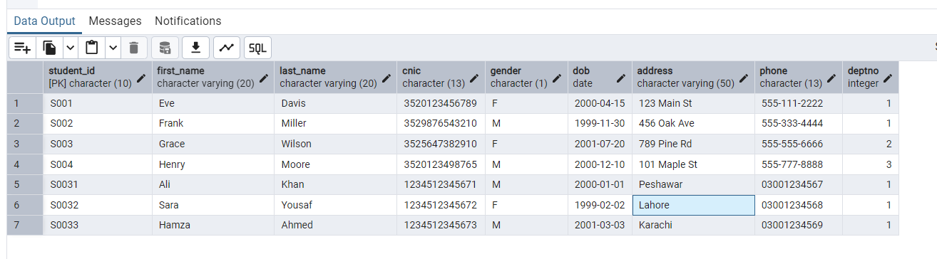DEPTNO NUMBER CONSTRAINT fk_deptno REFERENCES Department(DEPTNO));

**Graduate Student**

CREATE TABLE Graduate_Student

(

STUDENT_ID CHAR(10) CONSTRAINT pk_graduate_student PRIMARY KEY REFERENCES

Student(STUDENT_ID),

THESIS_ADVISOR CHAR(10) CONSTRAINT fk_thesis_advisor REFERENCES

Instructor(INSTRUCTOR_ID),

THESIS_STATUS VARCHAR(20) CONSTRAINT ck_thesis_status CHECK

(THESIS_STATUS IN ('COMPLETE', 'IN PROGRESS')) );

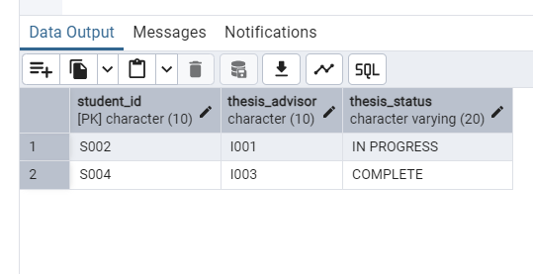

**Under Graduate Student**

CREATE TABLE Undergraduate_Student

(

STUDENT_ID CHAR(10) CONSTRAINT pk_undergraduate_student PRIMARY KEY REFERENCES Student(STUDENT_ID),

FYP_ADVISOR CHAR(10) CONSTRAINT fk_fyp_advisor REFERENCES

Instructor(INSTRUCTOR_ID)

);

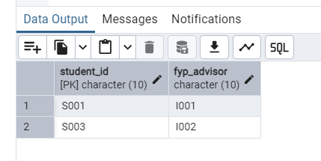

**Department**

CREATE TABLE department (

deptno INTEGER CONSTRAINT pk_department PRIMARY KEY,

deptname VARCHAR(50) NOT NULL CONSTRAINT nn_deptname,

hod CHAR(10) CONSTRAINT fk_hod REFERENCES instructor(instructor_id)

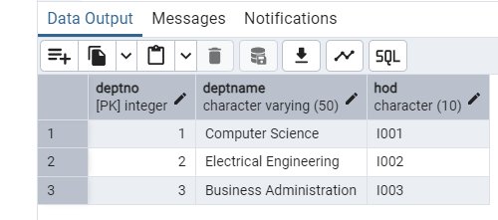);

**Instructor**

CREATE TABLE instructor (

instructor_id CHAR(10) CONSTRAINT pk_instructor PRIMARY KEY,

first_name VARCHAR(20) NOT NULL CONSTRAINT nn_instructor_first_name,

last_name VARCHAR(20) NOT NULL CONSTRAINT nn_instructor_last_name,

email VARCHAR(30) CONSTRAINT uq_instructor_email UNIQUE,

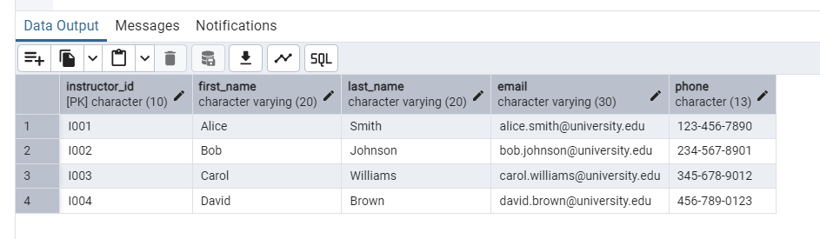 phone CHAR(13) NOT NULL CONSTRAINT nn_instructor_phone);

**Room**

CREATE TABLE room (

roomno INTEGER CONSTRAINT pk_room PRIMARY KEY,

capacity INTEGER CONSTRAINT ck_capacity CHECK (capacity > 0)

);

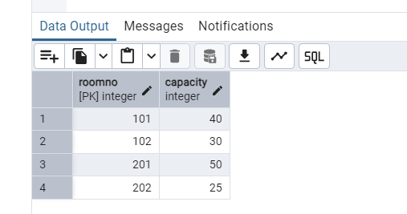

**Course**

CREATE TABLE Course

(

COURSE_CODE VARCHAR2(10) CONSTRAINT pk_course PRIMARY KEY,

COURSE_TITLE VARCHAR2(50) CONSTRAINT nn_course_title NOT NULL,

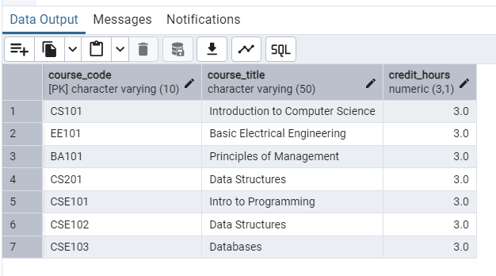CREDIT_HOURS NUMBER CONSTRAINT ck_credit_hours CHECK (CREDIT_HOURS BETWEEN 0.5 AND 3) );

**Pre_Requisite_Course**

CREATE TABLE pre_requisite_course (

course_code VARCHAR(10) CONSTRAINT fk_course_code REFERENCES course(course_code),

pre_req VARCHAR(10) CONSTRAINT fk_pre_req REFERENCES course(course_code),

CONSTRAINT pk_pre_requisite_course PRIMARY KEY (course_code, pre_req));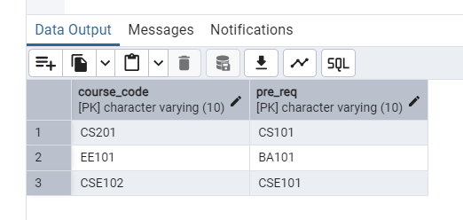

**Class**

CREATE TABLE class (

instructor_id CHAR(10) CONSTRAINT fk_class_instructor REFERENCES instructor(instructor_id),

course_code VARCHAR(10) CONSTRAINT fk_class_course REFERENCES course(course_code),

room_no INTEGER CONSTRAINT fk_class_room REFERENCES room(roomno)

CONSTRAINT pk_class PRIMARY KEY (instructor_id, course_code));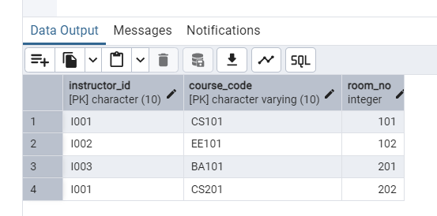

**Enrollment**

CREATE TABLE enrollment (

student_id CHAR(10) CONSTRAINT fk_enrollment_student REFERENCES student(student_id),

course_code VARCHAR(10) CONSTRAINT fk_enrollment_course REFERENCES course(course_code),

enrollment_date DATE,

grade CHAR(1) CONSTRAINT ck_grade CHECK (grade IN ('A', 'B', 'C', 'D', 'F')),

status CHAR(4) CONSTRAINT ck_status CHECK (status IN ('PASS', 'FAIL')),

CONSTRAINT pk_enrollment PRIMARY KEY (student_id, course_code)

);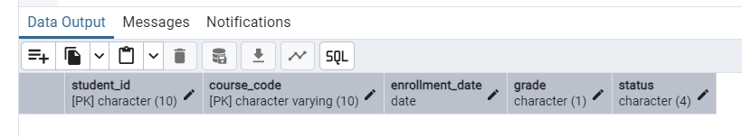

**8. Views of relational schema**

**1. Student Details:**

CREATE OR REPLACE VIEW student_details AS

SELECT

S.STUDENT_ID,

S.FIRST_NAME || ' ' || S.LAST_NAME AS FULL_NAME,

S.CNIC,

S.GENDER,

S.DOB,

S.ADDRESS,

S.PHONE,

D.DEPTNAME AS DEPARTMENT_NAME,

H.FIRST_NAME || ' ' || H.LAST_NAME AS DEPARTMENT_HEAD

FROM

Student S

JOIN Department D ON S.DEPTNO = D.DEPTNO JOIN Instructor H ON D.HOD = H.INSTRUCTOR_ID; select * from student_details

### 2. Enrollment Details

CREATE VIEW Enrollment_Details AS

SELECT

e.STUDENT_ID,

s.FIRST_NAME,

s.LAST_NAME,

e.COURSE_CODE,

c.COURSE_TITLE,

e.ENROLLMENT_DATE,

e.GRADE,

e.STATUS

FROM Enrollment e

JOIN Student s ON e.STUDENT_ID = s.STUDENT_ID JOIN Course c ON e.COURSE_CODE = c.COURSE_CODE select * from enrollment_details

**3. Graduate Students Details:**

CREATE OR REPLACE VIEW Graduate_Student_Details AS

SELECT gs.STUDENT_ID,

CONCAT(s.FIRST_NAME,CONCAT(' ',s.LAST_NAME)) "STUDENT NAME", s.CNIC,

s.GENDER,

s.DOB,

s.ADDRESS,

s.PHONE,

CONCAT(i.FIRST_NAME,CONCAT(' ',i.LAST_NAME)) "ÄDVISOR NAME", gs.THESIS_STATUS

FROM Graduate_Student gs

JOIN Student s ON gs.STUDENT_ID = s.STUDENT_ID

JOIN Instructor i ON gs.THESIS_ADVISOR = i.INSTRUCTOR_ID;

**4. Pre-Requisite Courses Details:**

CREATE OR REPLACE VIEW Pre_Requisite_Course_Details AS

SELECT

c.COURSE_TITLE AS COURSE_TITLE, prc2.COURSE_TITLE AS PRE_REQ_TITLE

FROM Pre_Requisite_Course prc

JOIN Course c ON prc.COURSE_CODE = c.COURSE_CODE

JOIN Course prc2 ON prc.PRE_REQ = prc2.COURSE_CODE;

**9. Relational Data Model showing associations**

Student

Student_ID

FirstName

LastName

CNIC

Gender

DOB

Address

PHONE#

DeptNo

Graduate

Student

Student_ID

Thesis_Advisor_ID

Thesis_Status

Under

Graduate

Student

Student_ID

FYP_Advisor

Instructor

Instructor_ID

FirstName

LastName

Email

Phone#

Department

DeptNo

Dept_Name

HOD

Course

Course_Code

Course_Title

Credit_Hours

Pre-Requisite

Course

Course_Code

Pre_Req

Room

RoomNo

Capacity

Class

Instructor_ID

Course_Code

RoomNo

Enrollment

Student_ID

Course_Code

Enrollment_Date

Grade

Status

## 10. Five Common Reports

### 1. QUERY TO RETRIEVE STUDENTS WHOSE THESIS IS COMPLETE

### SELECT

### S.FIRST_NAME || ' ' || S.LAST_NAME AS NAME,

### I.FIRST_NAME || ' ' || I.LAST_NAME AS ADVISOR,

### G.THESIS_STATUS

### FROM STUDENT S

### JOIN GRADUATE_STUDENT G ON G.STUDENT_ID = S.STUDENT_ID

### JOIN INSTRUCTOR I ON I.INSTRUCTOR_ID = G.THESIS_ADVISOR

### WHERE G.THESIS_STATUS = 'COMPLETE';

### 2. QUERY TO RETRIEVE ROOMS THAT ARE FREE YET

### SELECT R.ROOMNO, R.CAPACITY

### FROM ROOM R

### LEFT JOIN CLASS C ON R.ROOMNO = C.ROOM_NO

### WHERE C.ROOM_NO IS NULL;

### 3. QUERY TO RETRIEVE DEPARTMENT ID ,NAME ,HEAD AND NUMBER OF STUDENTS IN THAT DEPARTMENT

### SELECT

### d.DEPTNO,

### d.DEPTNAME,

### i.FIRST_NAME || ' ' || i.LAST_NAME AS HEAD_NAME,

### COUNT(s.STUDENT_ID) AS STUDENT_COUNT

### FROM Department d

### JOIN Instructor i ON d.HOD = i.INSTRUCTOR_ID

### LEFT JOIN Student s ON d.DEPTNO = s.DEPTNO

### GROUP BY d.DEPTNO, d.DEPTNAME, i.FIRST_NAME, i.LAST_NAME;

### 4. LIST INSTRUCTORS WHO ARE SUPERVISING AN FYP

### SELECT DISTINCT

### I.INSTRUCTOR_ID,

### I.FIRST_NAME || ' ' || I.LAST_NAME AS NAME

### FROM Instructor I

### JOIN Undergraduate_Student U ON I.INSTRUCTOR_ID = U.FYP_ADVISOR;

### 5. STUDENT WHO ARE FAILED IN ANY SUBJECT

## SELECT

## S.STUDENT_ID,

## S.FIRST_NAME || ' ' || S.LAST_NAME AS NAME,

## C.COURSE_TITLE,

## I.FIRST_NAME || ' ' || I.LAST_NAME AS TEACHER_NAME

## FROM STUDENT S

## JOIN ENROLLMENT E ON S.STUDENT_ID = E.STUDENT_ID

## JOIN COURSE C ON C.COURSE_CODE = E.COURSE_CODE

## JOIN CLASS CL ON E.COURSE_CODE = CL.COURSE_CODE

## JOIN INSTRUCTOR I ON I.INSTRUCTOR_ID = CL.INSTRUCTOR_ID

## WHERE E.GRADE = 'F';

## 11. Procedures

**1. PROCEDURE TO SHOW THE RESULT OF SPECIFIC STUDENT** CREATE OR REPLACE PROCEDURE Student_Result(p_STUDENT_ID CHAR)

LANGUAGE plpgsql

AS $$

DECLARE

rec RECORD;

no_enrollments BOOLEAN := TRUE;

BEGIN

FOR rec IN

SELECT e.COURSE_CODE, c.COURSE_TITLE, e.GRADE, e.STATUS

FROM Enrollment e

JOIN Course c ON e.COURSE_CODE = c.COURSE_CODE

WHERE e.STUDENT_ID = p_STUDENT_ID

LOOP

no_enrollments := FALSE;

RAISE NOTICE 'Course Code: %', rec.COURSE_CODE;

RAISE NOTICE 'Course Title: %', rec.COURSE_TITLE;

RAISE NOTICE 'Grade: %', rec.GRADE;

RAISE NOTICE 'Status: %', rec.STATUS;

RAISE NOTICE '-----------------------------';

END LOOP;

IF no_enrollments THEN

RAISE NOTICE 'No enrollments found for the given Student ID.';

END IF;

EXCEPTION

WHEN OTHERS THEN

RAISE NOTICE 'An error occurred: %', SQLERRM;

END;

$$;2. Procedure to Insert a student

CREATE OR REPLACE PROCEDURE InsertStudent( p_STUDENT_ID CHAR, p_FIRST_NAME VARCHAR2, p_LAST_NAME VARCHAR2, p_CNIC CHAR, p_GENDER CHAR, p_DOB DATE, p_ADDRESS VARCHAR2, p_PHONE CHAR,

p_DEPTNO NUMBER

) IS

BEGIN

INSERT INTO Student (STUDENT_ID,FIRST_NAME,LAST_NAME,CNIC,

GENDER,DOB,ADDRESS,PHONE,DEPTNO) VALUES

(p_STUDENT_ID, p_FIRST_NAME,p_LAST_NAME,p_CNIC,p_GENDER, p_DOB, p_ADDRESS,p_PHONE,p_DEPTNO);

EXCEPTION

WHEN NO_DATA_FOUND THEN

DBMS_OUTPUT.PUT_LINE('No data found.');

WHEN TOO_MANY_ROWS THEN

DBMS_OUTPUT.PUT_LINE('Too many Rows');

END;

/

### 3. PROCEDURE TO INSERT A RECORD IN ENROLLMENT TABLE AND

**CALCULATING GRADE BY MARKS** CREATE OR REPLACE PROCEDURE InsertGrade(

p_student_id CHAR,

p_course_id VARCHAR,

p_marks NUMERIC

)

LANGUAGE plpgsql

AS $$

DECLARE

v_grade CHAR(1);

v_status CHAR(4);

BEGIN

IF p_marks > 85 THEN

v_grade := 'A';

v_status := 'PASS';

ELSIF p_marks > 75 THEN

v_grade := 'B';

v_status := 'PASS';

ELSIF p_marks > 65 THEN

v_grade := 'C';

v_status := 'PASS';

ELSIF p_marks > 50 THEN

v_grade := 'D';

v_status := 'PASS';

ELSE

v_grade := 'F';

v_status := 'FAIL';

END IF;

INSERT INTO Enrollment (STUDENT_ID, COURSE_CODE, ENROLLMENT_DATE, GRADE, STATUS)

VALUES (p_student_id, p_course_id, CURRENT_DATE, v_grade, v_status);

EXCEPTION

WHEN OTHERS THEN

RAISE NOTICE 'Error occurred: %', SQLERRM;

END;

$$;

12. Functions

**1. FUNCTION TO GET AVERAGE GRADE POINT IN A COURSE** CREATE OR REPLACE FUNCTION GetAVGGradePoint(p_course_code VARCHAR)

RETURNS NUMERIC

LANGUAGE plpgsql

AS $$

DECLARE

v_average_grade NUMERIC;

BEGIN

SELECT AVG(

CASE GRADE

WHEN 'A' THEN 4.0

WHEN 'B' THEN 3.0

WHEN 'C' THEN 2.0

WHEN 'D' THEN 1.0

WHEN 'F' THEN 0.0

ELSE NULL

END

)

INTO v_average_grade

FROM Enrollment

WHERE COURSE_CODE = p_course_code;

RETURN v_average_grade;

EXCEPTION

WHEN NO_DATA_FOUND THEN

RETURN NULL;

END;

$$;

### 2. FUNCTION TO GET NUMBER OF COURSES BEING TAUGT BY A SPECIFIC INSTRUCTOR

### CREATE OR REPLACE FUNCTION GetClassCountForTeacher(p_instructor_id CHAR)

### RETURNS INTEGER

### LANGUAGE plpgsql

### AS $$

### DECLARE

### v_class_count INTEGER;

### BEGIN

### SELECT COUNT(*)

### INTO v_class_count

### FROM Class

### WHERE INSTRUCTOR_ID = p_instructor_id;

### RETURN v_class_count;

### EXCEPTION

### WHEN OTHERS THEN

### RETURN -1;

### END;

### $$;

### 3. FUNCTION TO COUNT THE NUMBER OF GRADUATE STUDENTS IN A DEPARTMENT

## CREATE OR REPLACE FUNCTION GetTotalGraduateStudentsInDept(p_deptno INTEGER)

## RETURNS INTEGER

## LANGUAGE plpgsql

## AS $$

## DECLARE

## v_student_count INTEGER;

## BEGIN

## SELECT COUNT(*)

## INTO v_student_count

## FROM Graduate_Student gs

## JOIN Student s ON gs.STUDENT_ID = s.STUDENT_ID

## WHERE s.DEPTNO = p_deptno;

## RETURN v_student_count;

## EXCEPTION

## WHEN OTHERS THEN

## RETURN -1;

## END;

## $$;

## 13. Triggers

### Trigger that no more than 20 students are enrolled in a course

CREATE OR REPLACE FUNCTION trg_CheckCourseEnrollmentLimit()

RETURNS TRIGGER

LANGUAGE plpgsql

AS $$

DECLARE

v_enrolled_students INTEGER;

BEGIN

SELECT COUNT(*)

INTO v_enrolled_students

FROM Enrollment

WHERE COURSE_CODE = NEW.COURSE_CODE;

IF v_enrolled_students >= 20 THEN

RAISE EXCEPTION 'Enrollment limit exceeded for this course. No more than 20 students can be enrolled.';

END IF;

RETURN NEW;

END;

$$;

CREATE TRIGGER trg_CheckCourseEnrollmentLimit

BEFORE INSERT ON Enrollment

FOR EACH ROW

EXECUTE FUNCTION trg_CheckCourseEnrollmentLimit();;

/

### Trigger to check if student has passed pre req

CREATE OR REPLACE FUNCTION trg_EnforcePrereqCompletion()

RETURNS TRIGGER

LANGUAGE plpgsql

AS $$

DECLARE

v_prereq_completed INTEGER;

BEGIN

SELECT COUNT(*)

INTO v_prereq_completed

FROM Enrollment e

JOIN Pre_Requisite_Course p ON e.COURSE_CODE = p.PRE_REQ

WHERE e.STUDENT_ID = NEW.STUDENT_ID

AND p.COURSE_CODE = NEW.COURSE_CODE

AND e.STATUS = 'PASS';

IF v_prereq_completed = 0 THEN

RAISE EXCEPTION 'Prerequisite courses not completed.';

END IF;

RETURN NEW;

END;

$$;

CREATE TRIGGER trg_EnforcePrereqCompletion

BEFORE INSERT ON Enrollment

FOR EACH ROW

EXECUTE FUNCTION trg_EnforcePrereqCompletion();